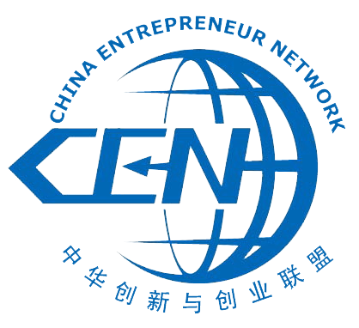
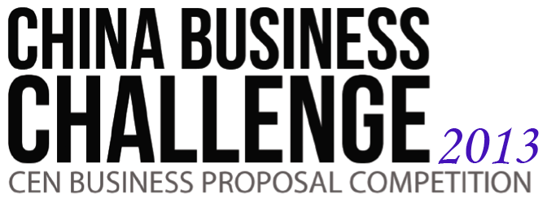

Preliminary Round Business proposal

Proposal Name:

Team Name:

Member Name | Email Address

Filled by mentors:
Level of Recommendation
Initial

This is template for a business proposal of approximately 2 pages long, suited for reading for 5 minutes by an investor to decide whether he or she should spend more time to think about your plan.

Executive summary
Who are you? What is your goal? What makes you different? What kind of service/product are you trying to deliver?

Value proposition
How does the business define and address specific business opportunities, or social and environmental in China? What will a customer obtain by using your service/product? What makes time or money a customer pays to you worthwhile?

Differentiation
Are there any similar product/services? Why would people choose yours instead of previously existing ones?

Market & Opportunity

What is your target market (population, age, gender, income level, etc.)? Who are your competition, and what is your competitive advantage?

Business model
- Key activity (What are you going to do in most of the time? List the most time-consuming works you need to finish to reach your goal.)
- Key resource (What are you going to utilize? What is the proof that you already have or will have those resources?)
- Key partner (Up-stream/down-stream supplier/customer )
- Competitors (Who are your competitors? How do you competitively position yourself in the market?)
- Organizational structure
- Cost Structure (Cost allocation, variable cost, fixed cost)
- Revenue Stream (How do you plan to generate revenue?)
- Organizational Structure

